**EXPERIMENT NO --13:**

**CIOT DEVICES IN NETWORKING USING CISCO PACKET TRACER.**

**AIM:**

**controlling fan ,light &applications of cisco tracer.**

**Materials required:: Cisco tracer software.**

Procedure ::

1.open the cisco tracer .

2.Then ,network devices-wireless devices-homegateway and place it on the site.

3.then ,end devices—home—celing fan -and windows and light other home appliences.

4.then set them as bellow

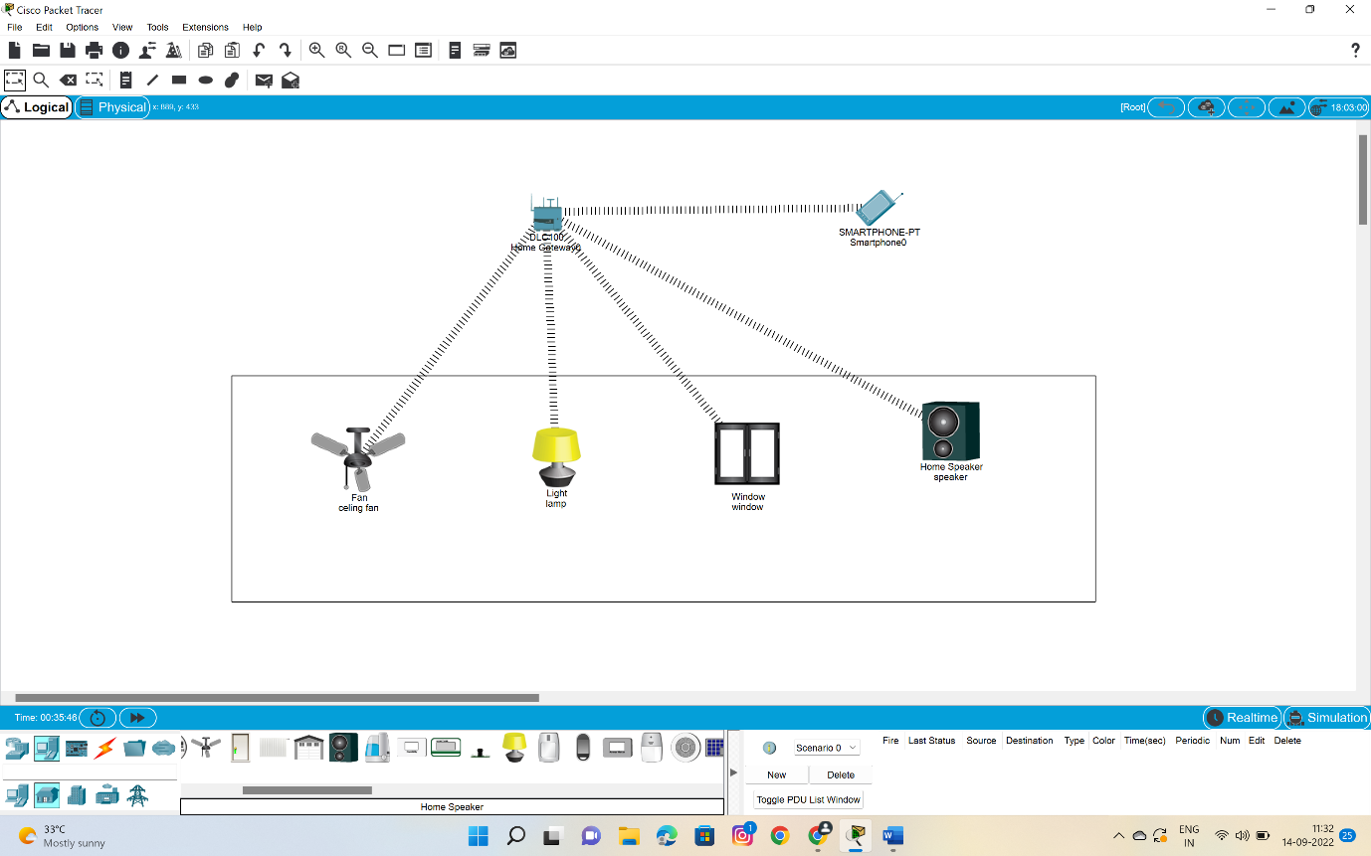

5.Then click on the fan -i/o configure –choose the wireless –then configr and wireless0 .repeat the same to the window,and lamp also.the the dotted lines will be formed btwn the homegatway and fan and window

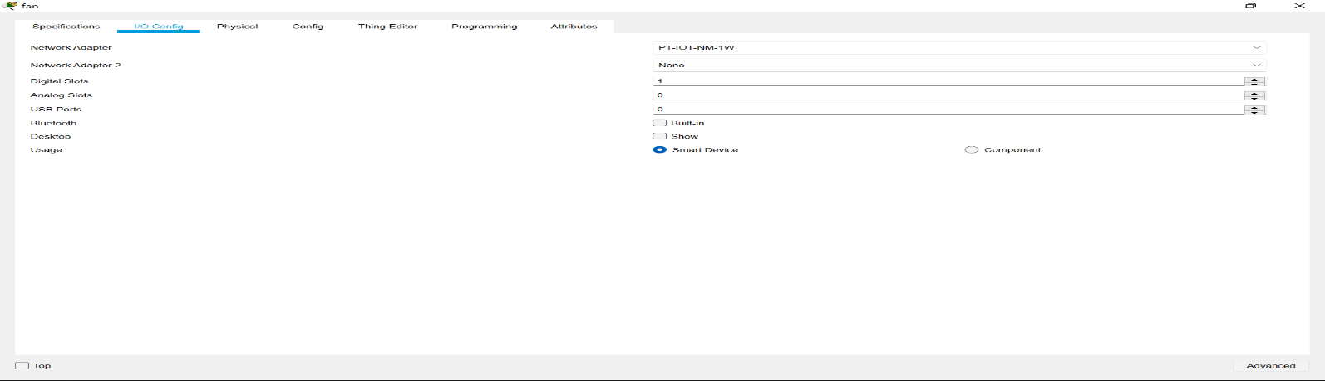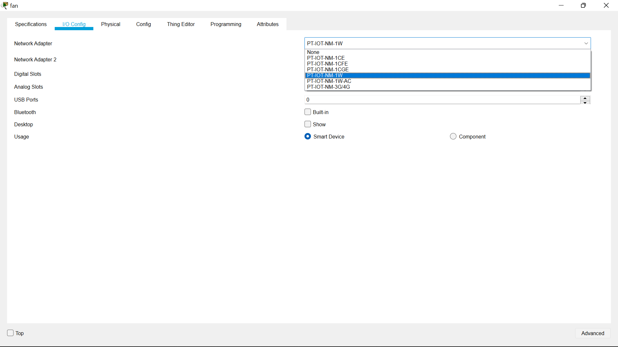

6.Then move to the end devices –click the smartphone to operate the wireless devices.

7.click on the smart phone to configure with homegateway give “HomeGateway” in the ssid space in wireless0.

8.connetion is established.



9.then click on the smart phone open desktop –iot monitor—login .

10.then you will find switches of celing fan and the window switches along with lamp switch .

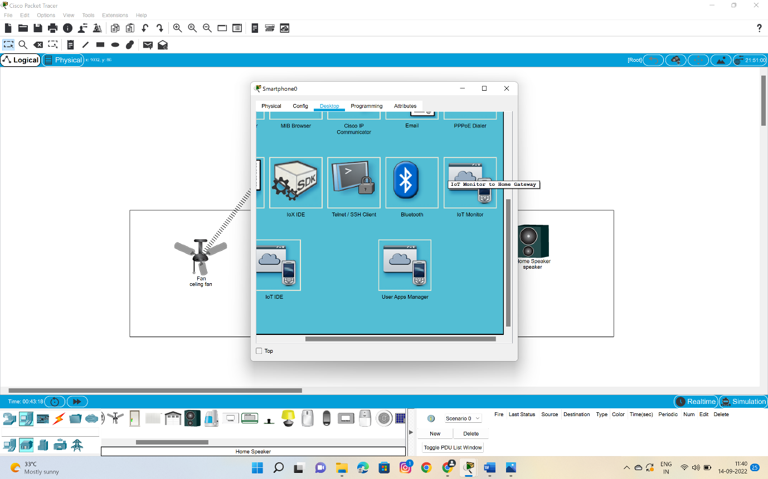

11.below are the switches to access the fan ,window,lamp and speaker too.

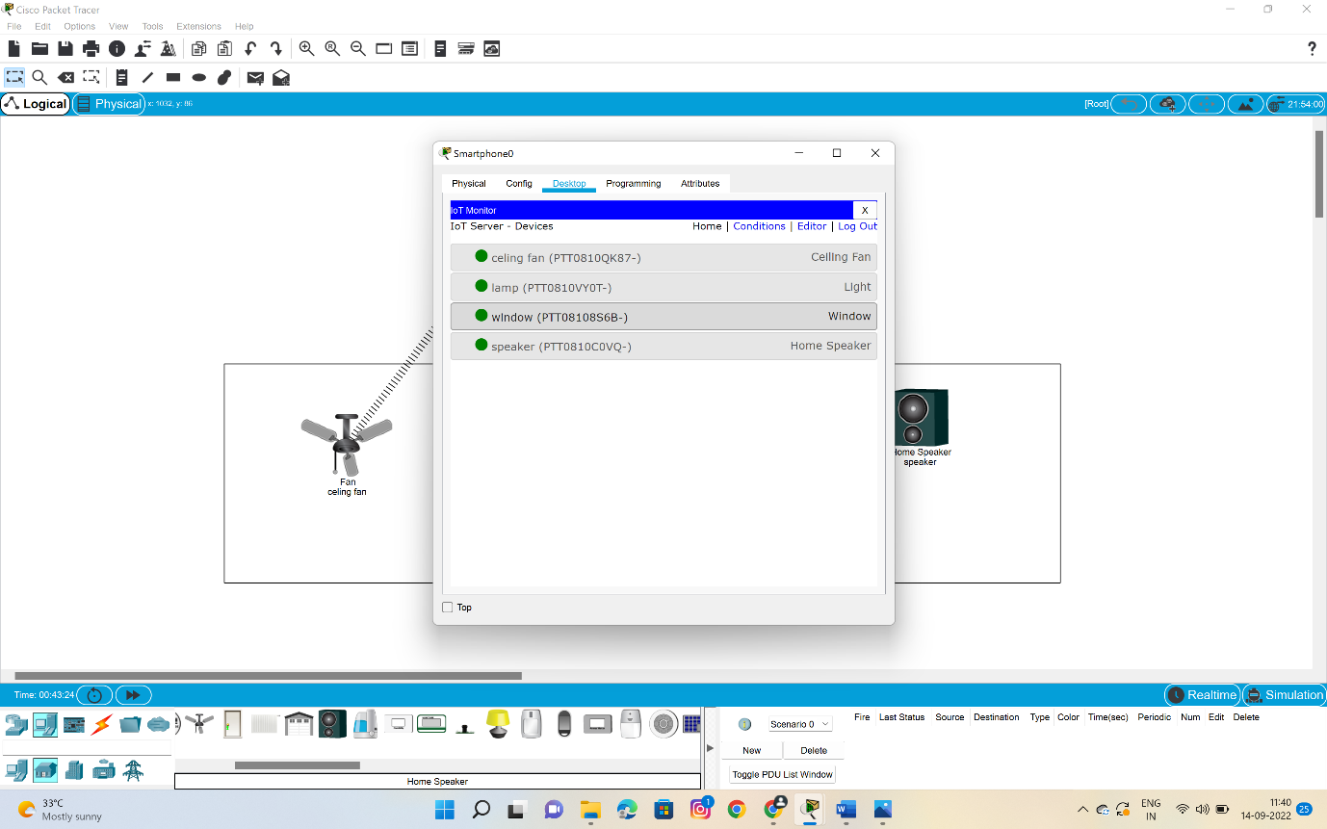

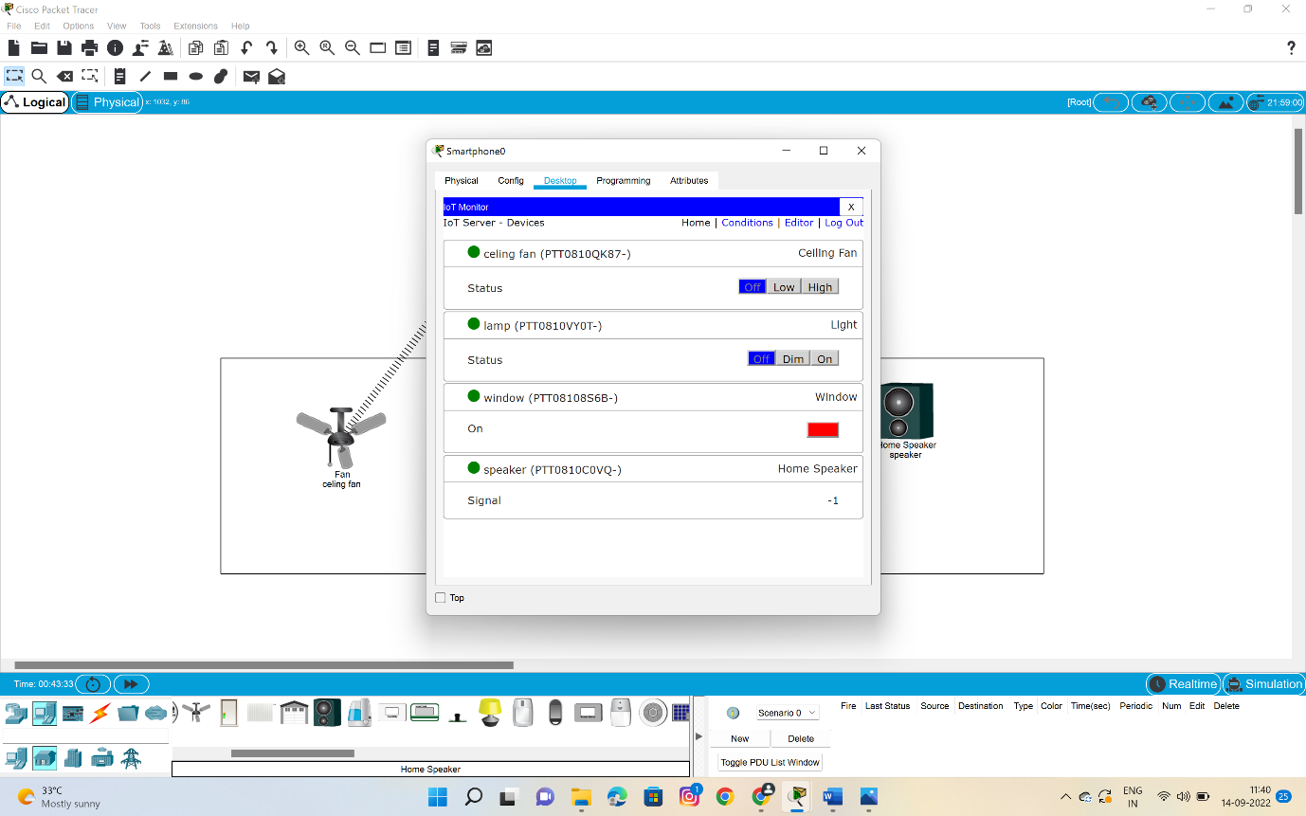

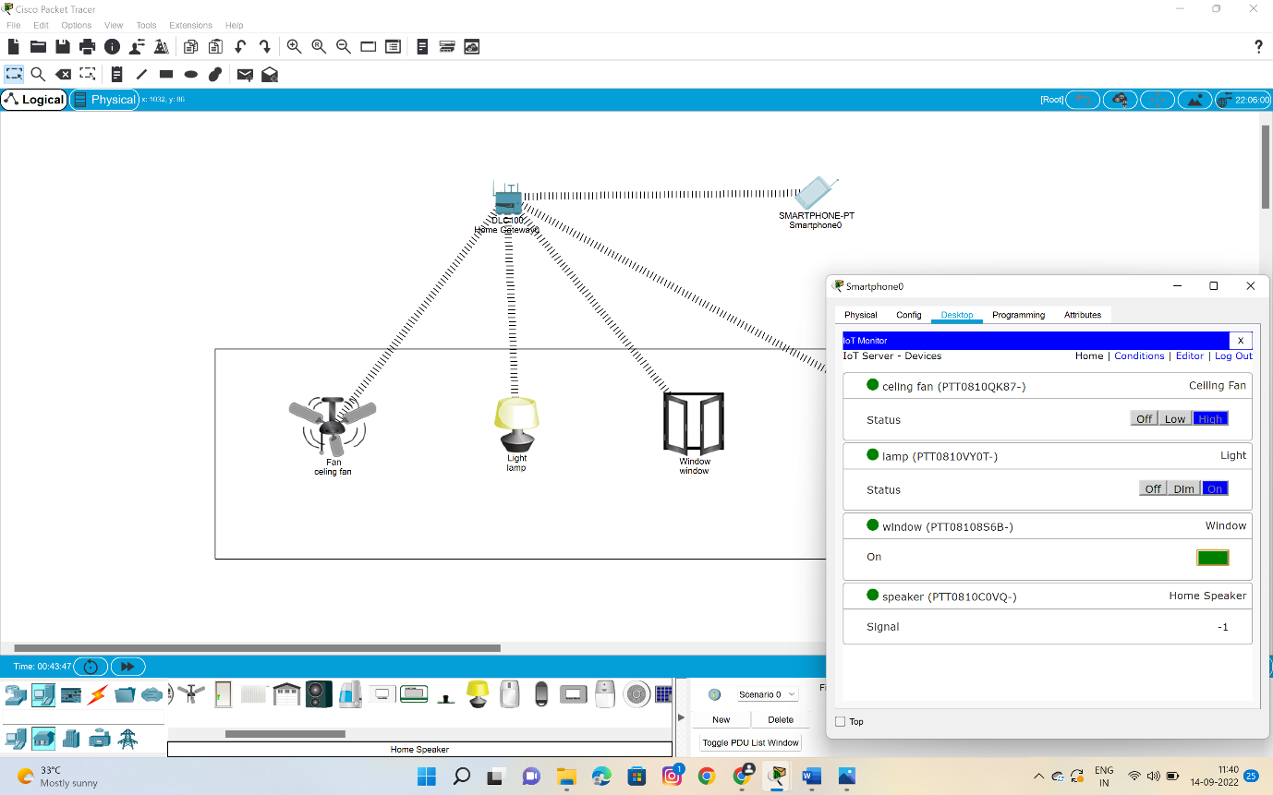

**12.In this picture we will be able to find that all the appliences are working .**

RESULT::

So successfully we have done an experiment for controlling the fan switch ,window and additionally we have added the speaker also……